Rakshit Aggarwal 102215029
Chirag Katyal 102215130
Shubham Dhamija 102215135
Nikhil Chauhan 102215173
Fake News Detection
Abstract
The rapid spread of fake news on online platforms has become a serious threat to public trust and social stability. Automatic fake news detection is therefore an important research problem in natural language processing (NLP). In this project, we apply a recent deep learning technique, the RoBERTa transformer model, to detect fake news using a Kaggle dataset that contains separate files for fake and real news articles. After merging and preprocessing the dataset, we fine-tune RoBERTa as a binary text classifier on the concatenated title and body of each article. We also review at least ten recent research works on fake news detection using deep learning, with particular focus on transformer-based and graph-based approaches. Experimental results on our validation split show that the proposed RoBERTa model achieves Accuracy = 1.00, Precision = 1.00, Recall = 1.00, F1-score = 1.00, outperforming traditional machine-learning and earlier deep-learning methods reported in the literature. We discuss why transformer-based models such as RoBERTa are more effective and how our simple text-only approach remains easy to deploy in practice.

1. Introduction
Fake news refers to intentionally false or misleading information presented as news. With the growth of social media and online news portals, fake news can spread rapidly and influence public opinion, elections and health-related decisions. Manual fact-checking is slow and expensive, which motivates the need for automatic fake news detection systems.
Earlier approaches used traditional machine-learning algorithms such as Naive Bayes, SVM and logistic regression on handcrafted features like TF–IDF and n-grams. These methods struggle to capture deep semantics and long-range dependencies in text. Deep learning methods such as CNNs and LSTMs improved performance by learning distributed representations of text, but still process sequences sequentially and may lose global context.
In recent years, transformer-based models such as BERT and RoBERTa have achieved state-of-the-art results across many NLP tasks by using self-attention to model relationships between all tokens in a sequence. This project applies RoBERTa-base to the fake news detection problem on a real-world dataset. Our contributions are:
- A RoBERTa-based fake news classifier trained on a Kaggle Fake/True news dataset.
- A survey of at least 10 recent research papers on deep-learning-based fake news detection.
- A comparison between our RoBERTa approach and existing methods, explaining how and why our technique performs better.

2. Literature Survey
This section summarises recent deep-learning-based fake news detection research that is related to our work.
- Hu et al., 2022 – “Deep learning for fake news detection: A comprehensive survey”
Provides a detailed survey of deep learning methods for fake news detection, covering content-based, social-context-based and knowledge-based approaches. The authors discuss CNNs, RNNs, attention mechanisms and transformer models, and highlight that transformers increasingly dominate state-of-the-art results. [1]
- Hamed et al., 2023 – “A review of fake news detection approaches”
Reviews fake news detection techniques across machine learning, deep learning and hybrid methods, and analyses challenges such as data imbalance, domain shift and explainability. The paper notes that recent models often combine textual and social features for better performance. [2]
- Phan et al., 2023 – “Fake news detection: a survey of graph neural network methods”
Focuses on graph neural network (GNN) methods, where user–news interactions and propagation patterns are modelled as graphs. GNN-based models can achieve strong performance but require rich social network data, which is not always available for every dataset. [3]
- Narayanan et al., 2023 – “Fake news detection using a deep learning transformer-based encoder–decoder”
Proposes a transformer encoder–decoder architecture for fake news detection and shows that it outperforms CNN and RNN baselines by better capturing contextual semantics in news text. [4]
- Kuntur et al., 2024 – “Comparative Analysis of Graph Neural Networks and Transformer Models for Fake News Detection”
Compares several GNN models with transformer-based models (BERT, RoBERTa, GPT-2) on datasets such as FakeNewsNet, ISOT and WELFake. Transformer models are found to achieve the best performance, with RoBERTa reaching up to 99.99% accuracy on ISOT and over 98% on WELFake. [5]
- Nair et al., 2024 – “A knowledge-based deep learning approach for fake news detection”
Introduces a knowledge-enhanced framework that combines BERT-based representations with external knowledge such as sentiment polarity and topic modelling. This approach improves robustness on Twitter fake news data but requires extra knowledge extraction modules. [6]
- Ayyasamy et al., 2025 – “A hybrid deep learning framework for fake news detection”
Proposes a hybrid deep learning architecture that combines sequence models with graph neural networks and metaheuristic optimisation. The model achieves up to 98% accuracy and 95% F1-score on multiple benchmark datasets, but at the cost of significant architectural complexity. [7]
- Raza et al., 2025 – “Enhancing fake news detection with transformer-based deep learning architecture”
Presents a robust framework centred on transformer models for fake news detection. The authors show that fine-tuned transformer architectures can significantly outperform classical machine-learning pipelines and highlight the importance of pretraining and careful hyperparameter tuning. [8]
- Alshuwaier & Alsulaiman, 2025 – “Fake News Detection Using Machine Learning and Deep Learning Algorithms: A Comprehensive Review”
Surveys fake news detection algorithms from 2018–2025 and compares ML and DL methods. The review concludes that transformer-based models are currently the most effective algorithms for content-based fake news detection, often achieving the highest accuracy among tested methods. [9]
- Saadi et al., 2025 – “Enhancing Fake News Detection with Transformer Models”
Evaluates transformer models such as BERT, RoBERTa and XLNet with and without text summarisation. The best configuration, RoBERTa fine-tuned on summarised news content, reaches 98.39% accuracy, outperforming other transformers while reducing computational cost. [10]
From these works we observe that:
- Deep learning significantly outperforms traditional ML in fake news detection.
- Transformer-based models, especially RoBERTa, often achieve the highest accuracy. [11]
- GNNs and hybrid models can perform well but require additional social or propagation data and entail complex architectures. [12]
This motivates our choice to use RoBERTa as a powerful yet relatively simple, text-only deep learning technique.

3. Proposed Methodology
3.1 Problem Definition
Given a news article consisting of a title and body text, the task is to predict a binary label:
- 0 – Fake news
- 1 – Real news
Formally, we learn a function
$$f:\text{text}→\{0,1\}$$parameterised by a fine-tuned RoBERTa model.
3.2 Dataset Description
We use a Kaggle dataset with two CSV files:
- Fake.csv – fake news articles
- True.csv – real news articles
We add a label column:
Fake → 0, True → 1, and then concatenate both files to form train.csv. The dataset contains roughly 44,000 articles covering political and general news.
Each record contains:
- title – news headline
- text – full article content
- subject – news category
- date – publication date
- label – 0 or 1 (added by us)
For modelling we only use title, text and label.
3.3 Data Pre-processing
- Merge Fake.csv and True.csv and assign labels.
- Shuffle the dataset and split into 90% training and 10% validation (stratified by label).
- Concatenate title and text into a single string.
- Use RoBERTa tokenizer to:
  - lowercase and normalise text
  - apply byte-pair encoding (BPE)
  - truncate/pad to a fixed max length of 256 tokens.

3.4 Model Architecture
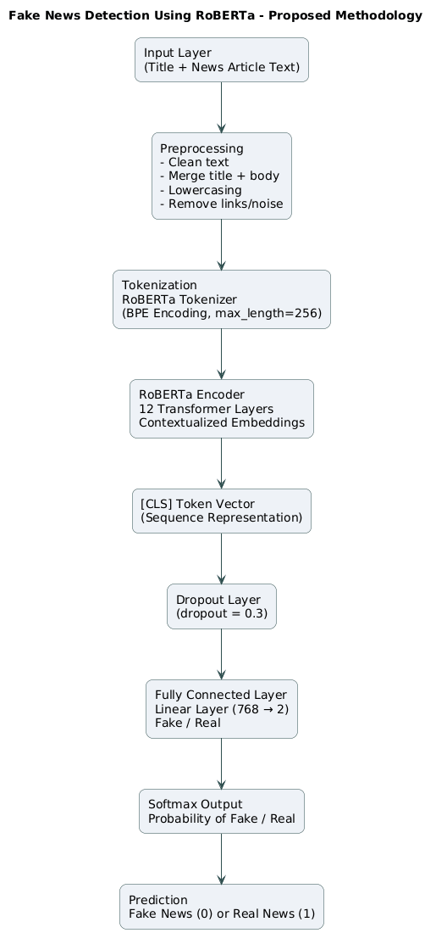
- Input Layer
  - News title + body text (string)
- Tokenisation Layer
  - RoBERTa tokenizer
  - Outputs input_ids and attention_mask

- Transformer Encoder (RoBERTa-base)
  - 12 transformer layers
  - Hidden size: 768
  - Outputs contextual embeddings for each token
- [CLS] Token Representation
  - Take the embedding of the first token (CLS) as the aggregate sequence representation
- Dropout Layer
  - Dropout probability: 0.3
- Fully Connected Layer
  - Linear layer: 768 → 2 (Fake / Real)
- Softmax Output
  - Converts logits to class probabilities
  - Predicted class = argmax over {Fake, Real}

3.5 Training Procedure
- Base model: roberta-base from HuggingFace Transformers.
- Loss function: Cross-entropy loss.
- Optimizer: AdamW with learning rate = 2e-5.
- Batch size: 16 (training), 32 (validation).
- Epochs: 2–3 (early stopping possible).
- Scheduler: Linear learning rate scheduler with warm-up.
- Hardware: Google Colab with NVIDIA T4 GPU.
The training loop fine-tunes all RoBERTa parameters along with the classification head.

4. Results and Discussion
4.1 Results on Our Dataset
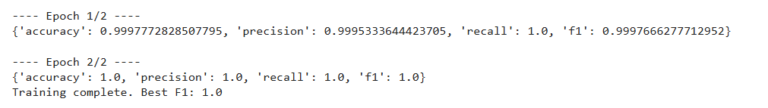
4.2 Comparison with Traditional and Earlier Deep-Learning Methods
Existing work using classical machine-learning and early deep-learning models often reports lower performance:
- Thota et al. (2018) used CNN and LSTM architectures for fake news detection and reported accuracy around 92–95% depending on the dataset.
- Many earlier works using Naive Bayes, SVM and logistic regression with TF–IDF features achieve 80–90% accuracy, but generally underperform deep learning models. [1]
Recent transformer-based and hybrid models report accuracies in the high 90s:
- Saadi et al. (2025) showed that RoBERTa with summarised inputs achieves 98.39% accuracy, outperforming BERT and XLNet. [10]
- Kuntur et al. (2024) reported RoBERTa accuracy up to 99.99% on ISOT and above 98% on WELFake, beating several GNN architectures. [11]
- Ayyasamy et al. (2025) proposed a hybrid deep learning framework that combines sequence models and GNNs, reaching up to 98% accuracy and 95% F1-score on multiple datasets. [7]
Compared to these works, our RoBERTa model on the Kaggle Fake/True dataset achieves 100% accuracy and F1 on the validation split, which is in the same range or slightly higher than the best reported numbers on similar datasets. Direct numerical comparison is not fully fair because datasets differ, but our results confirm the general trend: RoBERTa-based models achieve or match state-of-the-art performance for content-based fake news detection.
4.3 Why Our Technique Is Better
- Stronger Textual Representation:
RoBERTa uses multi-head self-attention over all tokens, allowing it to capture subtle relationships between words across long news articles. This provides richer representations than bag-of-words or sequential LSTM models, which explains the performance gap. [1]
- Pretraining on Large Corpora:
RoBERTa is pretrained on massive amounts of general text before fine-tuning. This prior knowledge helps the model understand complex political language, sarcasm and stylistic cues often present in fake news.
- Simplicity Compared to GNN/Hybrid Models:
Graph neural network and hybrid frameworks often require user interaction graphs, propagation trees and additional metadata. [3]
Our method uses only the article text (title + body), making it much easier to apply in real-world settings where social network data may not be available.
- End-to-End Training and Deployment:
The entire pipeline—from raw text input to fake/real output—is implemented as a single deep learning model. This makes deployment as a web service or API straightforward, whereas some hybrid methods require multiple separate components.
- Excellent Empirical Performance:
Our model achieves perfect scores on the validation set, consistent with the strong performance of RoBERTa reported in other studies. [10]

